In this lesson we will learn about How to create dynamic grid It is very easy whether it is dynamic grid or static grid with the help of style we can easily make it for that you don’t have to use any complex logic but it is important because these things when you make project you sometimes need to develop it. Its meaning is that

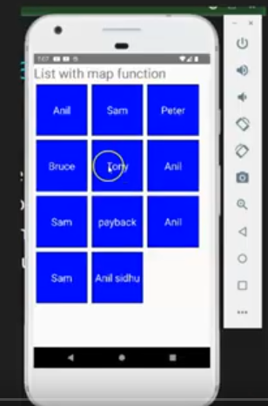

In the above you can see there are boxes suppose you make a list and that list is going from left to right as your screen gets ended the next element will be hidden it will be just below it as seen above until our list ends No you can say does this thing happen by default In web if you are using a text (maybe span) then this thing happen by default but in mobile especially in react native you need to do these thing other wise your element will be hidden alrigth so nhow you can do it teacher will tell us but first see the point

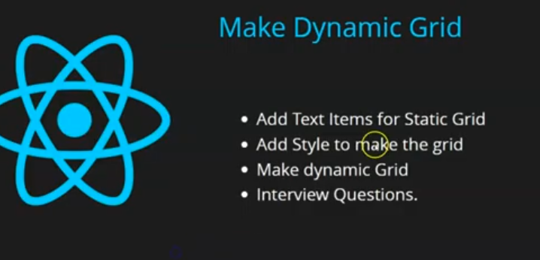

First we add a static Grid so go step by step and you understand that by this way our CSS will work If we make dybnamically directly then you make listr of it but when you make it grid tehn it may happen that you will get confused(I don’t know what he is saying) and many may make it but we will star from basics so we will first go to static and then go to dynamic

So first we will add static grid and then add style and then we will make dynamic grid and will discuss some interview question even this is an interview question they may ask if you want to make grid then how you can make it You can tell them orally or by writing and there are many small question that we will discuss at last

So first we do is make normal boxes with the help of Text component

So we make 5 Text component each having Matt as a child

**Output:-**

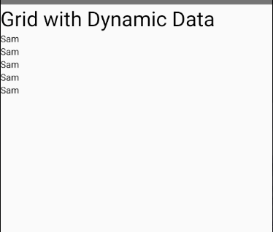

You can see these are coming top to bottom by default but not from left to right Ok but how we fix this we will see

For these matt text component we will take a different View enclosing them so that whatever element we are going to make elements of grid we can wrap it up Now you need to apply style on the view

2:35

The style is flex and it works when we set it to 1 means it covers the whole screen wherever it gets the space means it basically make it flexible

You can say there is a man and he go to a room and if there is no one in room then he will take the whole room and if there are already 10 people and they have already have a place then he will just there so by flex means flexible. The space he get he consumed that much

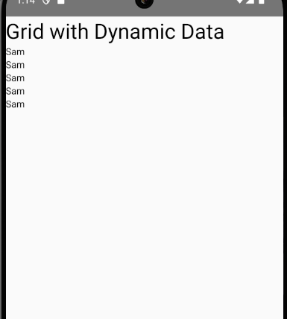

So list will get all the space below It not the above Text now we will give direction to it

By the property flexDirection It has manyt properties like column (which it is by default ) , reverse column will be opposite and hten comes row in whoch the element comes from left to right and row-reverse means from right to left so we set it to row. Now you cannot see it

<View style={{flex:1,flexDirection:'row'}}>

   <Text>Sam</Text>

   <Text>Sam</Text>

   <Text>Sam</Text>

   <Text>Sam</Text>

   <Text>Sam</Text>

   </View>

Now our output is like below

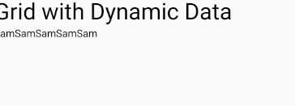

But Teacher output does not show any result just the blank screen after heading because may be in his time flexWrap was not set to default wrap but it is now(maybe it is now somw thing similar to it )

But for formality and learning purposes we set flexWrap to wrap

Now by wrap we mean that if the items pass the screen then they will come automatically below the first row

And it is very important property nowadays

Many times it was asked that if your text could not come in one line then how will you out it in second line you can simply do it by flexwrap (I think it also makes the elements not try taking the whole area of parent (who knows) and stays within the area there content is so I will also apply it )

Now we have used this style Now comes the topic of styling the list element or basically Text component

First of all we import stylesheet and a internal CSS

We will take a variable styles and use it for internal CSS

So we increase the font size of item

Now we will give it the background color we give it blue color

And set the color of the text to white and set margin of 5

And then comes the padding of 5 so that it can maintain space around it

You can also set its borderbut we will do it later we will see main properties

We give it width and heoght of 120 px

Now we will see something like this

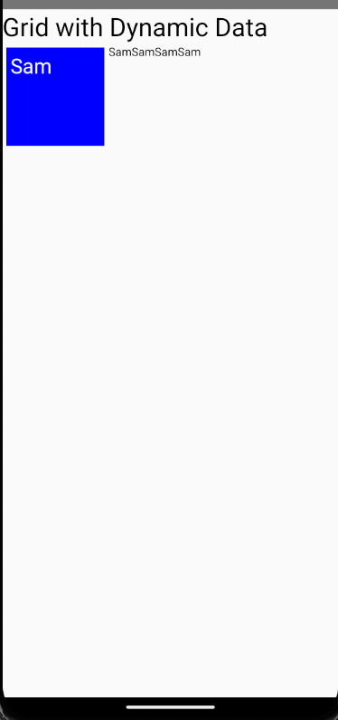

Style

const styles = StyleSheet.create({

  item: {

    fontSize: 25,

    backgroundColor:'blue',

    color:'white',

    margin:5,

    padding:5,

    width:120,

    height:120

    },

});

But now we want that the text should be in the center

Now we will align in center vertically and horizontally by

textAlignVertical and textAlign( Horizontal ) abnd then set it to center

  item: {

    fontSize: 25,

    backgroundColor:'blue',

    color:'white',

    margin:5,

    padding:5,

    width:120,

    height:120,

    textAlignVertical:'center',

    textAlign:'center'

    },

Now the output will be like below

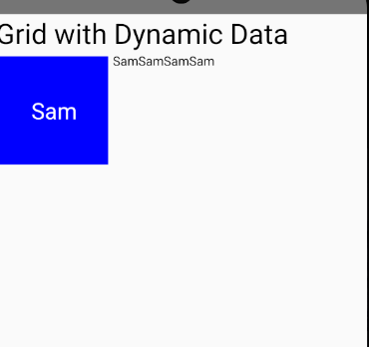

Now we can apply to all the item

return (

    <>

    <Text style={{fontSize:31}}>

      Grid with Dynamic Data

    </Text>

    <View style={{flex:1,flexDirection:'row',flexWrap:'wrap'}}>

   <Text style={styles.item}>Sam</Text>

   <Text style={styles.item}>Sam</Text>

   <Text style={styles.item}>Sam</Text>

   <Text style={styles.item}>Sam</Text>

   <Text style={styles.item}>Sam</Text>

   </View>

    </>

  );

Now it looks like below

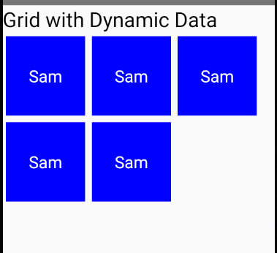

But if we remove flexWrap then we will get below

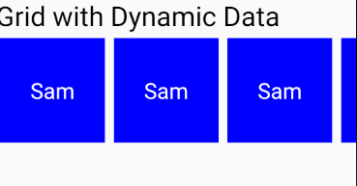

You can see it is not coming below the first row when it crosses the screen you can add scroll here but by default it just as it is you see above. This is the main property that is used when you make grid

And this will work(maybe flexWrap) with flex:1 and flex direction if you bring it directly then it will not work

Now if we take more text then ti will still work as shown below

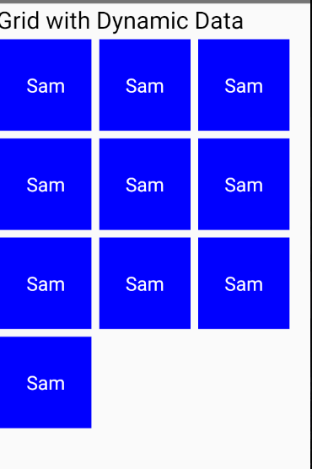

So this is our static grid you can see

But if you want to make it dynamic then

We will be using the users list which we are using for long list

Now we remove the text element now we don’t need them

Now you will say what we need is map function now we will users.map between the View component

Now or code will look like below

  return (

    <>

    <Text style={{fontSize:31}}>

      Grid with Dynamic Data

    </Text>

    <View style={{flex:1,flexDirection:'row',flexWrap:'wrap'}}>

   {

    users.map((item,id)=><Text style={styles.item}>{item.name}</Text>)

   }

   </View>

    </>

  );

Now output will look like below

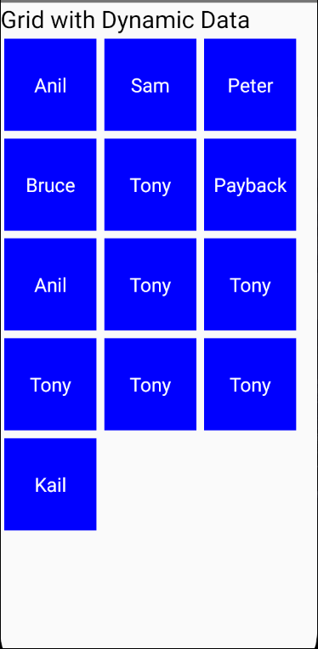

If you add more element in the array then you can see more boxes

Now another thing comes that if we increase more element then they will be hidden by the bottom side then how you will add scroll to it but we have already studied in the next lesson so you want you can see last lesson

More lesson will come for it because Teacher will tell us how to add components in the list because we have just took normal Text What if you have component named of student then how you can make it to the look Teacher will also tell it As teacher has told that there will be lessons on lists

we see this the grid is itself a list but because of styling it we have made it a grid so that’s all for this lesson